Project Title
Word-Level Plagiarism Checker for Short Documents
Project Report submitted for the partial fulfilment of grade for the course

Data Structures and Algorithms -3 (25CS2103E)
in

A.Y. 2026-2027

Submitted by
Anumola Jhansi Priya - 2520090205
Yuktha Alumuri – 2520090093

Team Number:17
Section:12

Under the guidance of

Ms. K. Chandusha

Asst. Prof, CS&IT
Hyderabad-500090, Telangana, India.

K L (Deemed to be) University
DEPARTMENT OF COMPUTER SCIENCE ENGINEERING / COMPUTER SCIENCE AND INFORMATION TECHNOLOGY/ARTIFICIAL INTELLIGENCE & DATA SCIENCE



DECLARATION

The Mini Project Report entitled “Word-Level Plagiarism Checker for Short Documents” is a record of Bonafide work of Anumola Jhansi Priya – 2520090205, Yuktha Alumuri - 2520090093. submitted in partial fulfillment for the award of B. Tech in Computer Science and Engineering/Computer Science and Information Technology/ Artifical Intelligence & data Science to the K L University. The results embodied in this report have not been copied from any other departments/University/Institute.

Anumola Jhansi Priya – 2520090205
Yuktha Alumuri - 2520090093

K L (Deemed to be) University
DEPARTMENT OF COMPUTER SCIENCE ENGINEERING / COMPUTER SCIENCE AND INFORMATION TECHNOLOGY
CERTIFICATE

This is to certify that the mini project based report entitled “Work-Level Plagiarism Checker for Short Documents” is a bonafide work done and submitted by Anumola Jhansi Priya – 2520090205, Yuktha Alumuri - 2520090093. in partial fulfillment of the requirements for the award of the degree of BACHELOR OF TECHNOLOGY in Department of Computer Science Engineering/ Computer Science and Information Technology/Artificial Intelligence & Data Science, K L (Deemed to be University), during the academic year 2026-2027.

Signature of the Supervisor

Signature of the HOD Signature of the External Examiner

ACKNOWLEDGEMENT

The success in this project would not have been possible but for the timely help and guidance rendered by many people. Our wish to express my sincere thanks to all those who has assisted us in one way or the other for the completion of my project.

Our greatest appreciation to my guide, Ms.K.Chandusha, Assistant Professor, CSIT,which cannot be expressed in words for his/her tremendous support, encouragement and guidance for this project.

We express our gratitude to Dr. Khaja Shareef (CSIT), Head of the Department for Computer Science and Information Technology for providing us with adequate facilities, ways and means by which we are able to complete this project-based Lab.

We thank all the members of teaching and non-teaching staff members, and also who have assisted me directly or indirectly for successful completion of this project. Finally, I sincerely thank my parents, friends and classmates for their kind help and cooperation during my work.

Anumola Jhansi Priya – 2520090205
Yuktha Alumuri - 2520090093

TABLE OF CONTENTS

S.No. | Contents | Page no.
1. | Abstract | 6
2. | Introduction | 7
3. | Literature survey | 8
4. | Problem Statement and Objectives | 10
5. | Hardware and Software requirements | 11
6. | Implementation | 12
7. | Results & Discussion | 17
8. | Conclusion & Future Scope | 19
9. | References | 20

1.ABSTRACT

The Word-Level Plagiarism Checker is a web-based application developed to identify similarities between two text documents using algorithmic techniques. The system is designed with React.js for the frontend and Java Spring Boot for the backend. It applies string-matching algorithms, dynamic programming techniques, suffix-based analysis, sequence alignment, and randomized hashing to compare text and identify matching patterns.
The application accepts a submitted document and a reference document, preprocesses the text, and analyzes the similarities between them. Algorithms such as Knuth-Morris-Pratt (KMP), Rabin–Karp, Aho–Corasick, Edit Distance, Suffix Array, Sequence Alignment, and Randomized Hashing are used to demonstrate different approaches to text comparison. The results are presented through a user-friendly interface that displays similarity estimates, matching patterns, and other algorithmic analysis.
The main objective of this project is to apply concepts from Design and Analysis of Algorithms (DSA-3) to a practical problem. The application demonstrates how algorithm selection and implementation can support text analysis. It is intended for educational use and provides an estimate of textual similarity rather than a definitive judgment of plagiarism.
Team Name:17(Section 12)
Team Logo (if any):
Team Members:
- Anumola Jhansi Priya - 2520090205
- Yuktha Alumuri - 2520090093

- INTRODUCTION

Plagiarism refers to the use of another person's words or ideas without appropriate acknowledgment. With the increasing availability of digital information, comparing documents manually has become time-consuming, especially when the documents contain large amounts of text. An automated plagiarism checker can help identify matching phrases and similar text efficiently.
The Word-Level Plagiarism Checker is developed as a web application that compares two text inputs and reports their similarities. The frontend is built using React.js, which provides an interactive interface for entering documents and viewing results. The backend uses Java Spring Boot to process the input and execute the implemented algorithms.
The project applies concepts from Design and Analysis of Algorithms, including string matching, dynamic programming, suffix-based techniques, and randomized hashing. Each algorithm performs a different role in analyzing text. Exact pattern-matching algorithms locate matching sequences, while dynamic programming techniques measure differences between text sequences.
The project also provides an opportunity to understand algorithm performance, computational complexity, and the integration of algorithms into a full-stack web application. It can be useful for students, educators, and developers who want to explore automated text comparison.

3.LITERATURE SURVEY

1. Turnitin Similarity
Turnitin is one of the widely used plagiarism and similarity detection systems in educational institutions. It compares submitted documents against a large database containing internet content, academic publications, and previously submitted student papers. The system generates a Similarity Report that highlights matching text and provides a similarity percentage. It also allows instructors to examine the sources of matching content and distinguish legitimate citations from possible plagiarism.

2. Grammarly Plagiarism Checker
Grammarly provides a plagiarism-checking feature that scans written content against websites, academic papers, and published sources. It identifies portions of text that may match external sources and helps users improve the originality of their writing. The system also provides citation suggestions in formats such as MLA, APA, and Chicago. This makes it useful for students, researchers, and content writers.

3. Copyscape
Copyscape is an online plagiarism detection system mainly designed to identify duplicate content on the Internet. It allows users to check web pages, paste text, or upload documents and compare the content with online sources. The system highlights matching portions and provides word-by-word comparisons between the submitted content and detected sources. It is widely used for website content, publishing, education, and research.

4. Quetext
Quetext is an online plagiarism checker that uses contextual analysis, fuzzy matching, and scoring techniques to detect both exact and similar content. It can identify potentially paraphrased content by comparing submitted text with large collections of web pages and academic sources. The system provides similarity scores and highlights matching sections using color-coded results. It also provides citation assistance to help users maintain originality.

5. DupliChecker
DupliChecker is an online plagiarism detection tool that allows users to paste text or upload documents in formats such as DOCX, PDF, and TXT. It compares submitted content with online sources and provides plagiarism results as percentages. The system can identify both exact and modified or paraphrased content and highlights duplicated phrases for easier analysis. It also supports different scanning modes and multiple languages.

6. PlagScan
PlagScan is a plagiarism detection platform designed for checking academic and professional documents. It analyzes uploaded documents and highlights possible matching content using different indicators for exact matches, altered text, and quotations. The system generates a plagiarism level and provides a list of sources where similarities were detected. This makes it useful for educational institutions and organizations that need detailed plagiarism reports.

7. Word-Level Plagiarism Detection Approach
Several plagiarism detection approaches focus on comparing documents at the word or phrase level rather than relying only on complete sentence matching. Such methods can identify similarities even when words are rearranged or slightly modified. Techniques such as tokenization, stop-word removal, stemming, indexing, and similarity measurement can improve the detection of copied and lightly paraphrased content. The proposed project follows this approach while focusing specifically on short documents and custom data structures for efficient processing.

- Problem Statement and Objectives

Problem Statement: Manually identifying copied or modified content between two documents can be difficult and time-consuming. Simple exact matching may fail to identify modified text, while word overlap alone may incorrectly indicate similarity between documents that discuss the same topic. Therefore, a system is needed to compare text using multiple algorithmic approaches and present understandable similarity results.
Problem Description: Traditional plagiarism checkers may fail to detect paraphrased, reordered, or slightly modified content, creating a need for a more accurate and efficient detection system.
Objectives:
- To develop a web-based plagiarism checker using React.js and Java Spring Boot.
- To compare submitted text with a reference document.
- To implement string-matching algorithms such as KMP, Rabin–Karp, and Aho–Corasick.
- To apply dynamic programming techniques such as Edit Distance and Sequence Alignment.
- To explore suffix-based analysis and randomized hashing for text comparison.
- To display matching patterns, similarity estimates, and algorithm-specific results.
- To study the computational complexity and practical behavior of the selected algorithms.
- To provide a simple, user-friendly interface for testing the algorithms.
The system is intended to support text comparison for educational purposes. Its output is an estimate of similarity and should not be treated as conclusive proof of plagiarism.

- HARDWARE AND SOFTWARE REQUIREMENTS

Hardware requirements
Processor | Intel Core i3 or equivalent and above
RAM | 4 GB minimum; 8 GB recommended
Storage | At least 2 GB of free space for project files and dependencies
Display | Standard monitor or laptop display
Internet | Required for initial dependency installation

Software requirements
Operating system | Windows 10/11, Linux, or macOS
Programming language | Java
Frontend | React.js, JavaScript, HTML, CSS
Backend | Java Spring Boot, REST API
Build tool | Apache Maven / Maven Wrapper
JavaScript tooling | Node.js and npm
Code editor | Visual Studio Code
Browser | Google Chrome or Microsoft Edge

- IMPLEMENTATION

The core engine is implemented in Java using four modules. The Spring Boot backend processes the submitted text and reference text, applies different string-matching algorithms, and calculates similarity information. The React.js frontend sends the text through a REST API and displays the analysis results. The four modules demonstrate the use of string matching, pattern searching, and dynamic programming concepts from DSA-3.

Module 1: Text Preprocessing (TextProcessor.java)
Text preprocessing converts the input into a standard format before comparing the documents. It converts text to lowercase, removes punctuation, and normalizes extra spaces. This makes the comparison more consistent.
package com.plagiarism.demo.service;

public class TextProcessor {

public String cleanText(String text) {
if (text == null) {
return "";
}

return text.toLowerCase()
.replaceAll("[^a-z0-9\\s]", " ")
.replaceAll("\\s+", " ")
.trim();
}

public String[] tokenize(String text) {
String cleaned = cleanText(text);

if (cleaned.isEmpty()) {
return new String[0];
}

return cleaned.split("\\s+");
}
}
Working: The cleanText() method removes punctuation and converts the text to lowercase. The tokenize() method divides the cleaned text into individual words, which are used by the comparison algorithms.

Module 2: KMP Pattern Matching (KMPAlgorithm.java)
The Knuth–Morris–Pratt (KMP) algorithm searches for a pattern in a text without repeatedly comparing characters that have already been matched. It uses an LPS (Longest Proper Prefix which is also a Suffix) array to improve searching efficiency.
package com.plagiarism.demo.algorithm;

public class KMPAlgorithm {

public int countMatches(String text, String pattern) {
if (text == null || pattern == null || pattern.isEmpty()) {
return 0;
}

int[] lps = buildLPS(pattern);
int i = 0;
int j = 0;
int count = 0;

while (i < text.length()) {
if (text.charAt(i) == pattern.charAt(j)) {
i++;
j++;
}

if (j == pattern.length()) {
count++;
j = lps[j - 1];
} else if (i < text.length()
&& text.charAt(i) != pattern.charAt(j)) {
if (j != 0) {
j = lps[j - 1];
} else {
i++;
}
}
}

return count;
}

private int[] buildLPS(String pattern) {
int[] lps = new int[pattern.length()];
int length = 0;
int i = 1;

while (i < pattern.length()) {
if (pattern.charAt(i) == pattern.charAt(length)) {
lps[i++] = ++length;
} else if (length != 0) {
length = lps[length - 1];
} else {
lps[i++] = 0;
}
}

return lps;
}
}
Working: The buildLPS() method creates the LPS array. The countMatches() method uses it to count occurrences of the reference pattern in the submitted text. The algorithm has time complexity \(O(n+m)\), where \(n\) is the text length and \(m\) is the pattern length.

Module 3: Rabin–Karp Pattern Matching (RabinKarpAlgorithm.java)
The Rabin–Karp algorithm uses hashing to compare text patterns efficiently. Instead of directly comparing every character at each position, it calculates hash values and checks matching windows.
package com.plagiarism.demo.algorithm;

public class RabinKarpAlgorithm {

private static final long BASE = 256;
private static final long MOD = 1_000_000_007L;

public int countMatches(String text, String pattern) {
if (text == null || pattern == null
|| pattern.isEmpty() || pattern.length() > text.length()) {
return 0;
}

int n = text.length();
int m = pattern.length();

long patternHash = 0;
long windowHash = 0;
long highestPower = 1;

for (int i = 1; i < m; i++) {
highestPower = (highestPower * BASE) % MOD;
}

for (int i = 0; i < m; i++) {
patternHash = (patternHash * BASE + pattern.charAt(i)) % MOD;
windowHash = (windowHash * BASE + text.charAt(i)) % MOD;
}

int count = 0;

for (int i = 0; i <= n - m; i++) {
if (patternHash == windowHash
&& text.regionMatches(i, pattern, 0, m)) {
count++;
}

if (i < n - m) {
windowHash = (windowHash
- text.charAt(i) * highestPower % MOD + MOD) % MOD;

windowHash = (windowHash * BASE
+ text.charAt(i + m)) % MOD;
}
}

return count;
}
}
Working: The algorithm calculates the pattern hash and the first text-window hash. It updates the hash as the window moves through the text. When hashes match, it verifies the actual characters to avoid counting hash collisions as matches. Its expected running time is efficient for many inputs, although worst-case performance can be \(O(nm)\).

Module 4: Edit Distance (EditDistance.java)
The Edit Distance algorithm uses dynamic programming to find the minimum number of insertions, deletions, and substitutions required to transform one text into another. It helps identify differences between similar texts.
package com.plagiarism.demo.algorithm;

public class EditDistance {

public int calculate(String first, String second) {
if (first == null) {
first = "";
}

if (second == null) {
second = "";
}

int m = first.length();
int n = second.length();

int[][] dp = new int[m + 1][n + 1];

for (int i = 0; i <= m; i++) {
dp[i][0] = i;
}

for (int j = 0; j <= n; j++) {
dp[0][j] = j;
}

for (int i = 1; i <= m; i++) {
for (int j = 1; j <= n; j++) {
int cost = first.charAt(i - 1)
== second.charAt(j - 1) ? 0 : 1;

dp[i][j] = Math.min(
Math.min(
dp[i - 1][j] + 1,
dp[i][j - 1] + 1
),
dp[i - 1][j - 1] + cost
);
}
}

return dp[m][n];
}
}
Working: A two-dimensional DP table stores the minimum editing cost for each pair of prefixes. The final cell, dp[m][n], gives the edit distance. The time complexity is \(O(mn)\), and the space complexity is \(O(mn)\).

How these modules work together
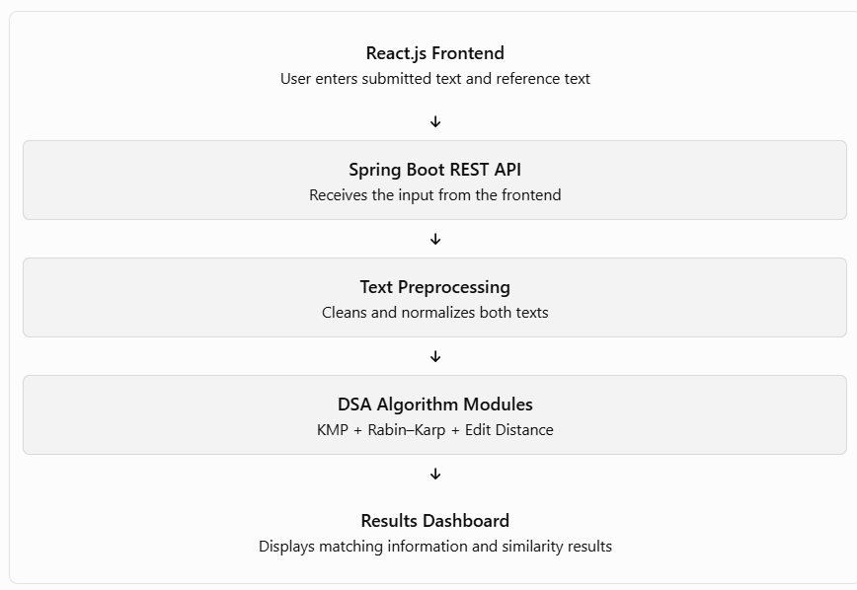

6.RESULTS & DISCUSSION
Output application run screen shots with their explanation in 2 lines.

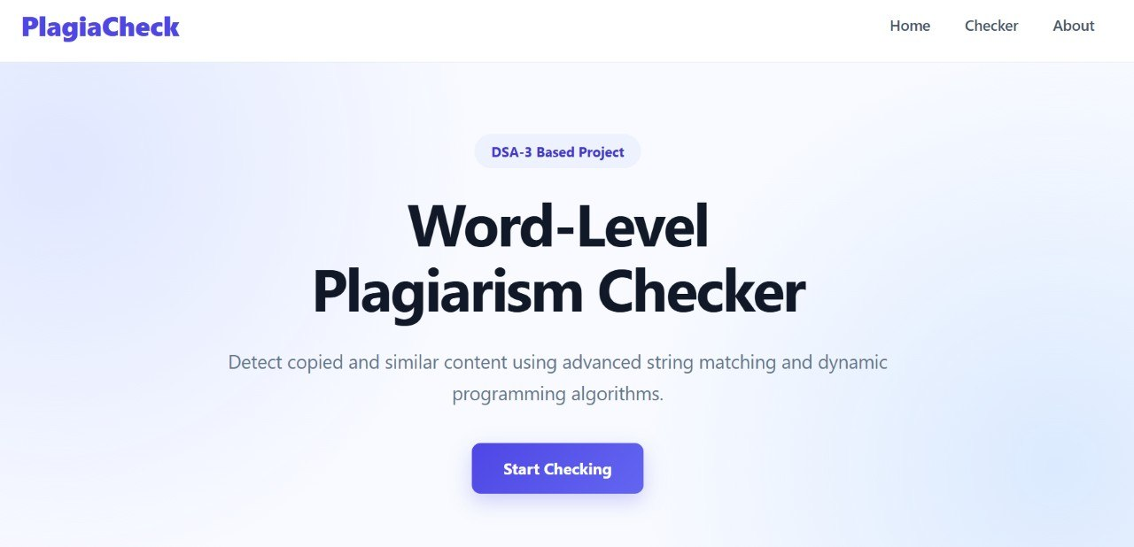

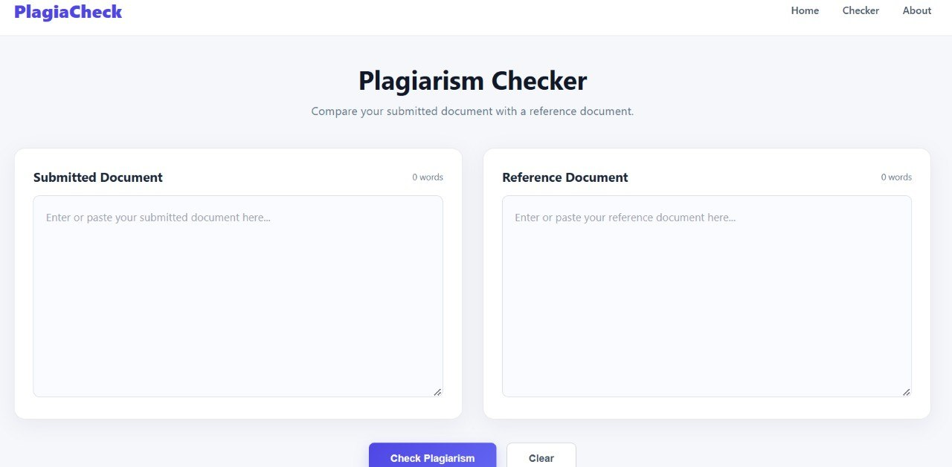

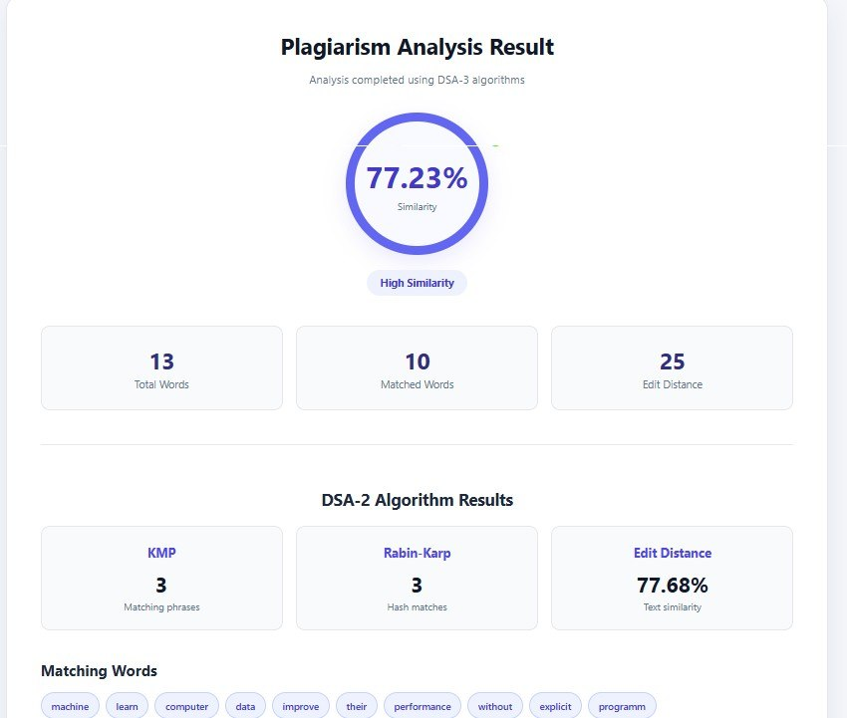

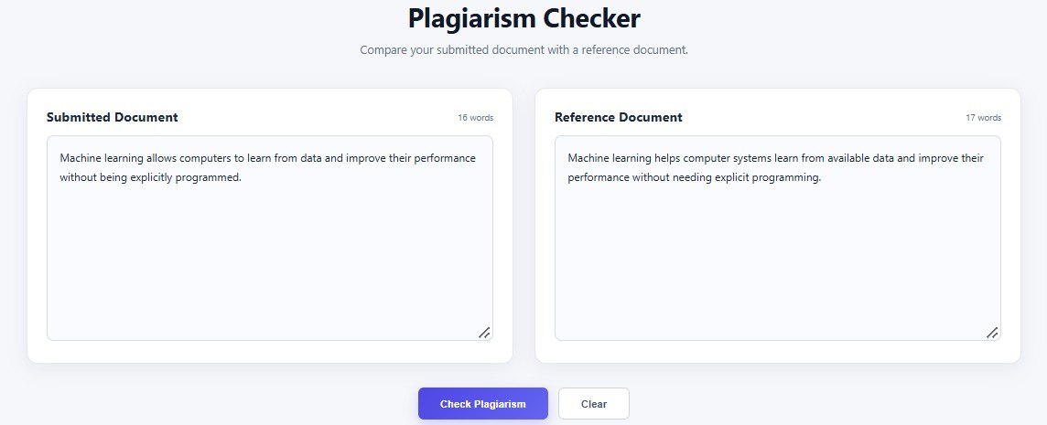

- CONCLUSION & FUTURE SCOPE

Conclusion
The Word-Level Plagiarism Checker demonstrates how Design and Analysis of Algorithms concepts can be applied to document comparison. The application combines a React.js frontend with a Java Spring Boot backend to provide an interface for entering text and viewing algorithmic analysis.
The project explores string matching, dynamic programming, suffix-based techniques, sequence alignment, and randomized hashing. These techniques illustrate different methods of identifying matching patterns and measuring differences between documents. The modular implementation also provides an opportunity to study algorithm complexity, accuracy, and practical limitations.
The project serves as an educational demonstration of algorithm design and full-stack application development. Its similarity results should be interpreted as indicators of textual overlap rather than definitive judgments of plagiarism.

Future Scope
- Document Upload: Support PDF, DOCX, and TXT files instead of requiring manual text entry.
- Advanced Text Comparison: Add more robust phrase and sentence-level comparison methods.
- Source Identification: Compare documents against a permitted collection of reference documents.
- Improved Visualization: Highlight matching words and phrases directly in the submitted text.
- Performance Evaluation: Measure execution time and memory usage for documents of different sizes.
- Large-Document Processing: Explore parallel algorithms and optimized indexing techniques.
- Improved Scoring: Calibrate the similarity formula using a labeled test dataset and avoid counting correlated algorithm outputs as independent evidence.
- User Management and Reports: Add user accounts, saved comparisons, and downloadable result reports.

- REFERENCES

- Knuth, D. E., Morris, J. H., and Pratt, V. R. (1977). “Fast Pattern Matching in Strings.” SIAM Journal on Computing, 6(2), 323–350.
- Rabin, M. O., and Karp, R. M. (1987). “Efficient Randomized Pattern-Matching Algorithms.” IBM Journal of Research and Development, 31(2), 249–260.
- Aho, A. V., and Corasick, M. J. (1975). “Efficient String Matching: An Aid to Bibliographic Search.” Communications of the ACM, 18(6), 333–340.
- Wagner, R. A., and Fischer, M. J. (1974). “The String-to-String Correction Problem.” Journal of the ACM, 21(1), 168–173.
- Gusfield, D. (1997). Algorithms on Strings, Trees, and Sequences: Computer Science and Computational Biology. Cambridge University Press.
- Needleman, S. B., and Wunsch, C. D. (1970). “A General Method Applicable to the Search for Similarities in the Amino Acid Sequence of Two Proteins.” Journal of Molecular Biology, 48(3), 443–453.
- Cormen, T. H., Leiserson, C. E., Rivest, R. L., and Stein, C. (2022). Introduction to Algorithms, 4th edition. MIT Press.
- Spring Team. Spring Boot Reference Documentation. https://docs.spring.io/spring-boot/
- React Team. React Documentation. https://react.dev/

